**2048 Game**

Table of Contents

Version history 3

1. 2048 Game 4

2. Flow chart 4

3. Repository: 5

4. How to Run the Project 5

5. Sample Output Using Python 5

6. Sample Output Using nodejs 6

## Version history

|  |  |  |  |
| --- | --- | --- | --- |
| Sl No | Date | Version | Author |
| 1 | 07-Feb-2022 | 0.1 | Ch. S V Gani Prabhakar |

## 2048 Game

2048 is played on a gray 4×4 grid, with numbered tiles that slide when a player moves them using the keys 1, 2, 3 and 4 as Left, Right, Up and Down respectively.

## Flow chart

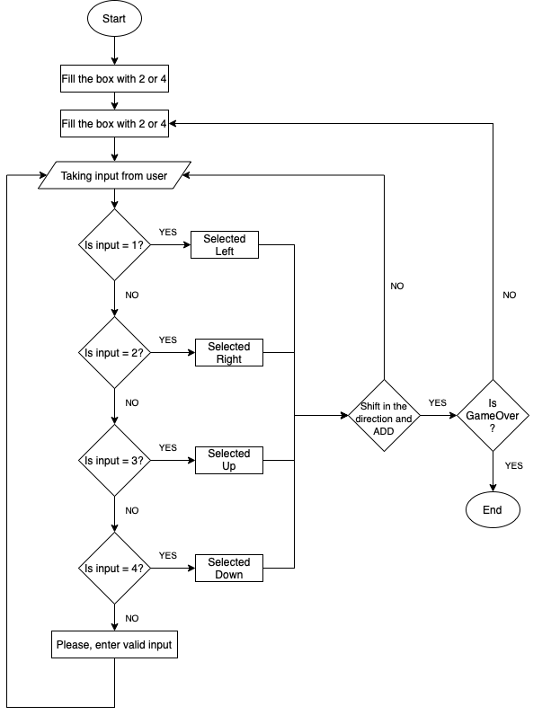

## Repository:

<https://github.com/svgani/ather2048>

## How to Run the Project

**Prerequisites**

* + Software: Python 3 and above, Node.
  + Operating System: Windows or Linux based.

**Execution on console**

* + Please execute the following command: python3 2048.py

**Execution on nodejs**

* + Please go to ui_2048 folder
  + Please install node modules: npm install
  + Please execute the following command npm start

## Sample Output Using Python

Note: The following output will be displayed when the game is started.  
  
sh-3.2$ python3 2048.py  
  
Score: 0  
-----------------------------  
| | | | |  
-----------------------------  
| | | | |  
-----------------------------  
| | | | 4 |  
-----------------------------  
| | | 2 | |  
-----------------------------  
  
Enter   
1 --> left  
2 --> right  
3 --> up  
4 --> down

Note: The following output will be displayed when the game is completed.  
  
-----------------------------  
| 4 | 2 | 8 | 4 |  
-----------------------------  
| 2 | 4 | 16 | 8 |  
-----------------------------  
| 8 | 16 | 2 | 4 |  
-----------------------------  
| 2 | 8 | 4 | 2 |  
-----------------------------  
Thanks for playing  
Score: 128

## 

## Sample Output Using nodejs

sh-3.2$ cd ui_2048/  
  
sh-3.2$ npm install  
  
up to date, audited 64 packages in 1s  
  
2 packages are looking for funding  
 run `npm fund` for details  
  
found 0 vulnerabilities  
  
sh-3.2$ npm start  
  
> ather_2048game@1.0.0 start  
  
> node index.js  
  
Server is running at port 8123

* The following output will be displayed when the game is started.

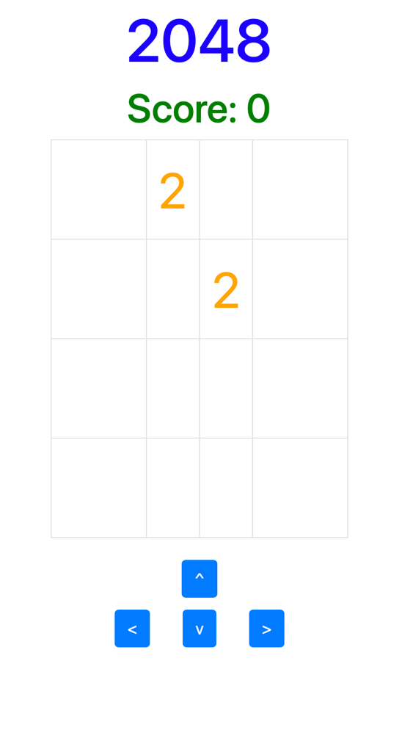

* The following output will be displayed when the game is completed.

